What will we be learning?  Unit 2 – Sports coaching & leadership | Why this? Why now?  This unit is delivered in Year 12 in the Spring and Summer terms after unit 1 has been completed. It is delivered during this time as it requires a range of facilities. | Key Words:  Coach  Leader  Autocratic  Democratic  Laissez-faire  Groups dynamics  Group cohesion  Social loafing  Risk assessment  Health and safety  Safeguarding  Adaptations  Review
What will we learn?
- LO1 – Know the roles and responsibilities of sports coaches & activity leaders
- LO2 – Understand principles which underpin coaching & leading
- LO3 – Be able to use methods to improve skills, techniques and tactics in sport
- LO4 – Be able to plan sports and activity sessions
- LO5 – Be able to prepare sports & activity environments
- LO6 – Be able to deliver sports & activity sessions
- LO7 – Be able to review sports & activity sessions

What opportunities are there for wider study?
Careers/degree courses
- Sports science
- Physiotherapy
- PE teacher
Further reading:
What is a sports coach? Roles & responsibilities of a sports coach (ucfb.ac.uk)
How to plan a coaching session – Plan It Coach
How will I be assessed?
- Teacher set assignments on Teams
- Observation of coaching/leading sessions

CAM TECH – SPORT
UNIT 2

LO1 – KNOW THE ROLES & RESPONSIBILITIES OF SPORTS COACHES & ACTIVITY LEADERS  - Roles of sports coaches & activity leaders  - Responsibilities of sport coaches & activity leaders  - How the roles & responsibilities involved in teaching & delivering sports differ | 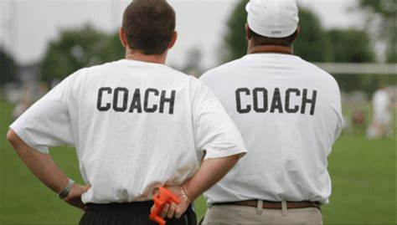
LO2 – UNDERSTAND PRINCIPLES WHICH UNDERPIN COACHING& LEARNING  - Principles of leadership and personality  - Group dynamics  - Attributes of coaches and leaders | 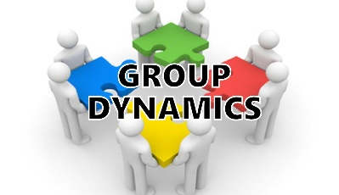
LO3 – BE ABLE TO USE METHODS TO IMPROVE SKILLS, TECHNIQUES & TACTICS IN SPORT
- Methods of identifying strengths & weaknesses in skills, techniques & deployment of tactics
- Classification of skills & its links to types of practice
- Methods for measuring improvements in skills, techniques & deployment of tactics

LO4 – BE ABLE TO PLAN SPORTS & ACTIVITY SESSIONS
- Review participants’ needs considering which could influence coaching sessions
- Key considerations when planning sports/activity sessions
- SMART goal setting

LO5 – BE ABLE TO PREPARE SPORTS & ACTIVITY ENVIRONMENTS  - Preparing equipment for sports/activity sessions  - Preparing the environment for sports/activity sessions  - Assessing & minimising risks before sports/activity sessions  - Appropriate safeguarding policies & procedures | 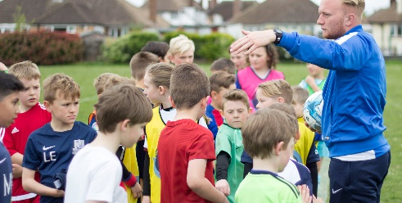
LO6 – BE ABLE TO DELIVER SPORTS & ACTIVITY SESSIONS
- Preparing participants for sports/activity sessions
- Delivering appropriate warm-up activities
- Delivering sport/activity sessions
- Concluding coaching sessions

LO7 – BE ABLE TO REVIEW SPORTS & ACTIVITY SESSIONS
- Reviewing sport/activity sessions

